**About Us**

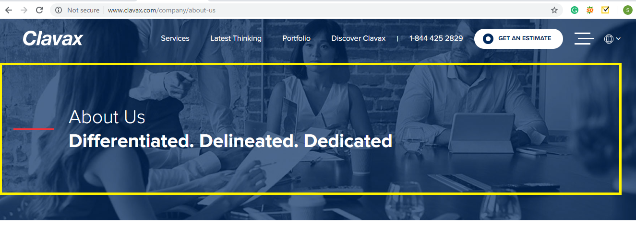

Text to be used

* **Transparency – Accountability - Integrity – Excellence**

**Next >>**

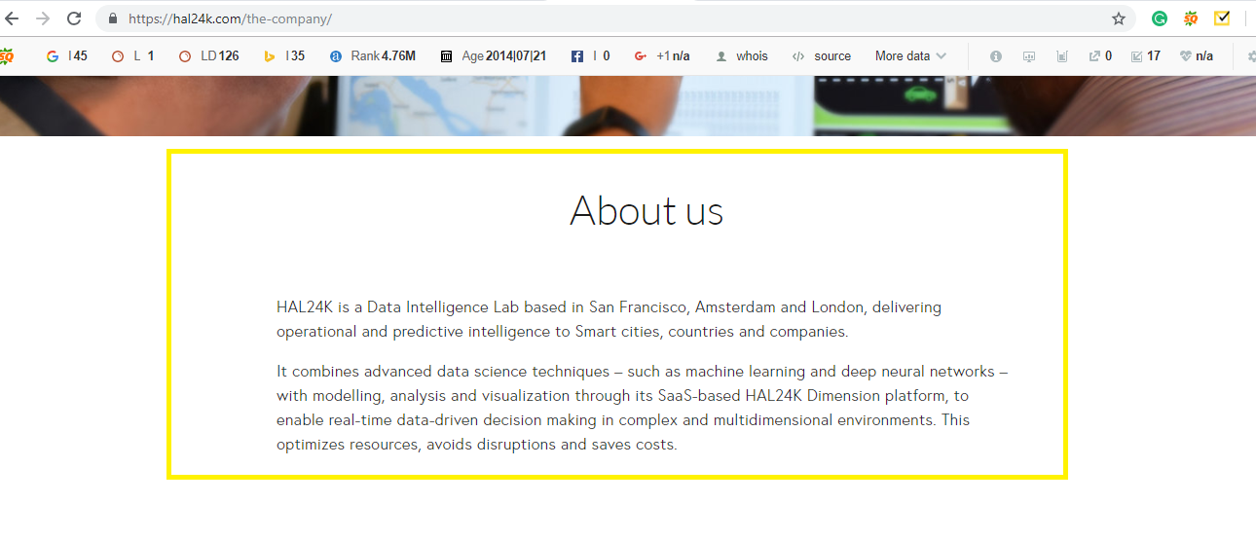

Text to be used

We are a bunch of wonderful IT talents who cooperate to reliably deliver top-notch software solutions. We owe our triumph to our dynamic culture that is rooted in self-organization. We are unique because we follow the customer-first approach.

NUNC Systems is an established Software development company that works with Enterprise systems and companies. As a privately-owned company, we provide IT Consultancy, Software Design, and Development as well as professional services and hardware deployment and maintenance to the various industries.

We are a partner with more than 100 top notch companies to serve and support them on their mobile application needs. As a Salesforce & SAP partner, it offers a unique value in development, integration, and implementation of CRM and ERP systems and RMS based projects in the following verticals: Retail, Finance, and Telecommunications.

Over the years, we have emerged as a successful name in the global IT collaboration scenario. Though our roots are in India, we have a business presence in worldwide.

Our team operates with enthusiasm and flexibility. We are focused on our customers, being their reliable partner for IT services and solutions, working together on a partnership basis, helping them face the challenges of the modern times. NUNC Systems has clients from the USA, Great Britain, Netherlands, Denmark, France, and EMEA regions. It is one of the very few companies which values and cares about its employees at par with its customers. Come and join us to explore new frontiers.

**We follow three simple principles**

1. True collaboration with customers and partners

2. Complete understanding of customers business

3. Persistence in finishing the job whatever it takes